- \Operation\Tube filling\Lifter\Tube filling – lifter – special functions
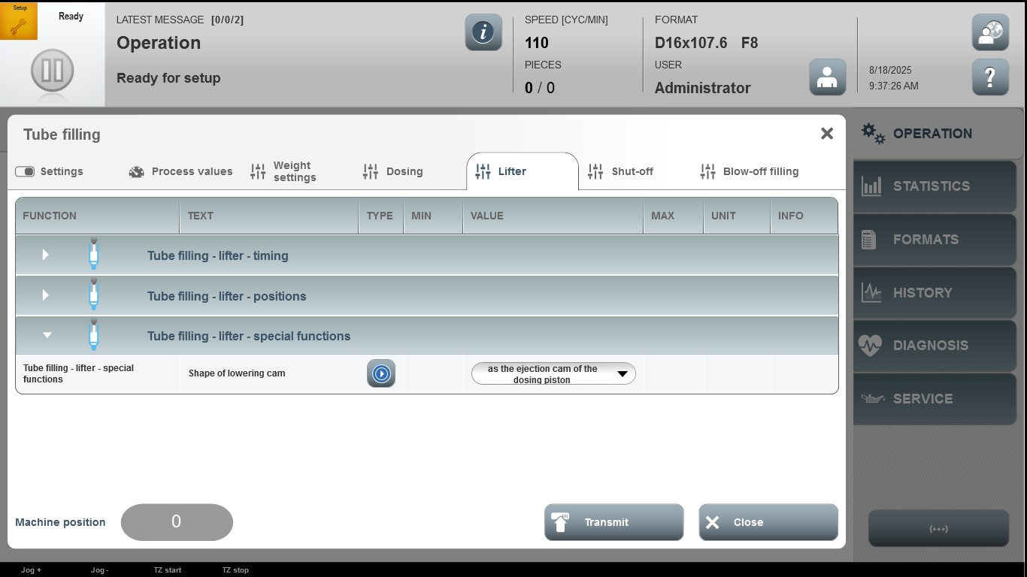

Acceptance criterion | Limits | Pass / Fail: Dev-No. | Date | Initials
Screen matches screenshot | N / A

